深 圳 大 学 实 验 报 告

课程名称： 数字图像处理

实验项目名称： Exp 4 Image Compression

学院： 电子与信息工程学院

专业： 电子信息工程

指导教师： 李斌

报告人： 卢嘉伟 学号： 班级： 文华

实验时间： 2025年 4月 28 日、5 月 12 日、5月 19 日

实验报告提交时间： 2025 年 5 月 25 日

教务部制
实验目的（Aim of Experiment）：
- Be familiar with some basic image fidelity assessment methods such as MSE, PSNR and SSIM.
- Be familiar with the process of JPEG compression.
- Be familiar with Discrete Cosine Transform, Huffman Coding, and Predictive Coding.

实验内容与要求（Experiment Steps and Requirements）：
- Compression Ratio and Relative Coding Redundancy. (a) Load the image bunny.png. Save it as a JPEG image with a quality factor of 90, 60, 10, respectively. Name the images as b90.jpg, b60.jpg, b10.jpg, respectively. (b) Display the original image and the compressed images. (c) Calculate the Compression Ratio and Relative Data Redundancy between the PNG image and JPEG images according to the file sizes. (Tips: os.path.getsize)
- Fidelity Criteria. (a) Load the saved JPEG images. Use functions from skimage.metrics to calculate MSE, PSNR, and SSIM values between the PNG image and JPEG images. (b) Implement a SSIM function by yourself according to [1].
[1] Wang Z, Bovik AC, Sheikh HR, Simoncelli EP. Image quality assessment: from error visibility to structural similarity. IEEE Trans Image Process. 2004 Apr;13(4):600-12.
- Simulation of a Part of JPEG Compression. (a) Load the grayscale image lenagray.tiff. (b) Shift the pixel intensity by -128. (c) Divide the image into non-overlapped 8 ∗ 8 subimages and perform 8 ∗ 8 block DCT on each subimage. (Tips: cv2.dct or scipy.fftpack.dct) (d) Use a quantization table with QF=50 for quantization. (e) Perform lossless predictive coding (difference coding) of DC coefficients by using the coefficient in the previous subimage as reference (a raster scan mannar). (f) Sort 63 AC coefficients in each block in a ZigZag order. Converted them into a one-dimensional vector. (g) Save all the compressed data into a Numpy data format (refered to as NPY/NPZ (.npy or .npz) file) (Tips: np.save or np.savez). (h) Compress the npy/npz file to a zip file (refered to as NPZzip). Compress the TIFF image to another zip file (refered to as TIFFzip). (i) Calculate the Compression Ratio between the TIFF image and the NPY/NPZ file according to the file sizes. Calculate the Compression Ratio between the TIFF image and the NPZzip file according to the file sizes. Calculate the Compression Ratio between the TIFFZzip and the NPZzip according to the file sizes. (j) Load the above saved file. Decode it to a recovered image. (k) Compute the MSE and PSNR of the recovered image, and display it with the original image side by side.

实验代码及数据结果（Experiment Codes and Results）：
(1)Compression Ratio and Relative Coding Redundancy
Code:
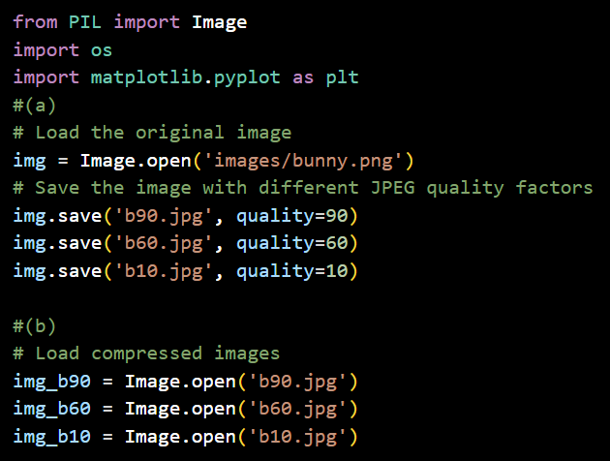
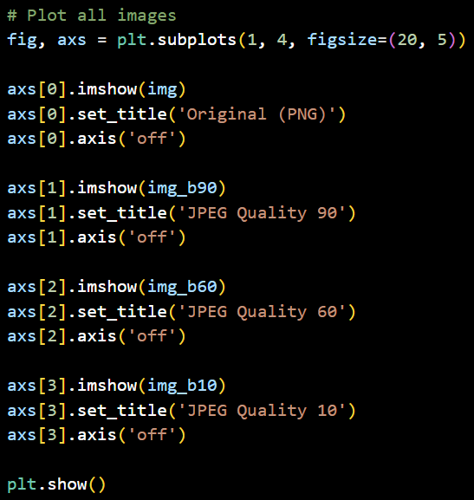
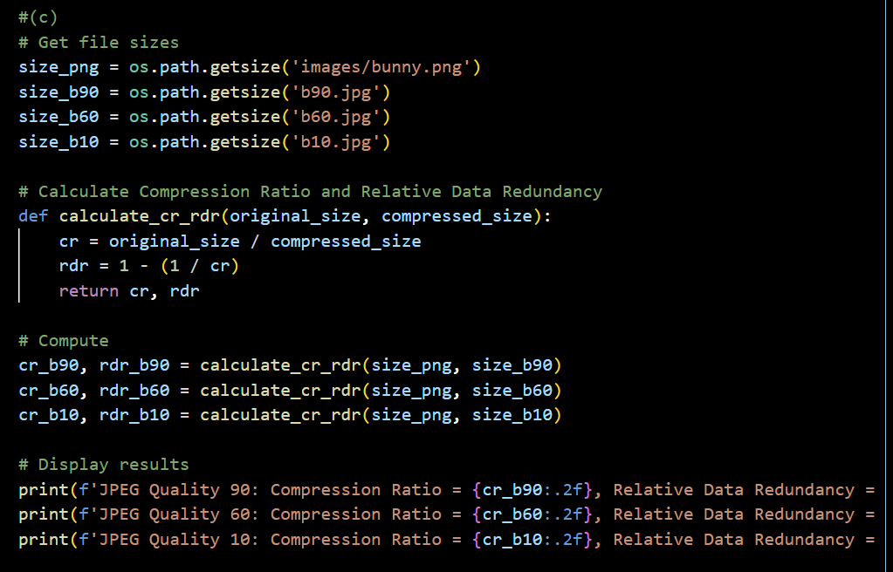
Results:
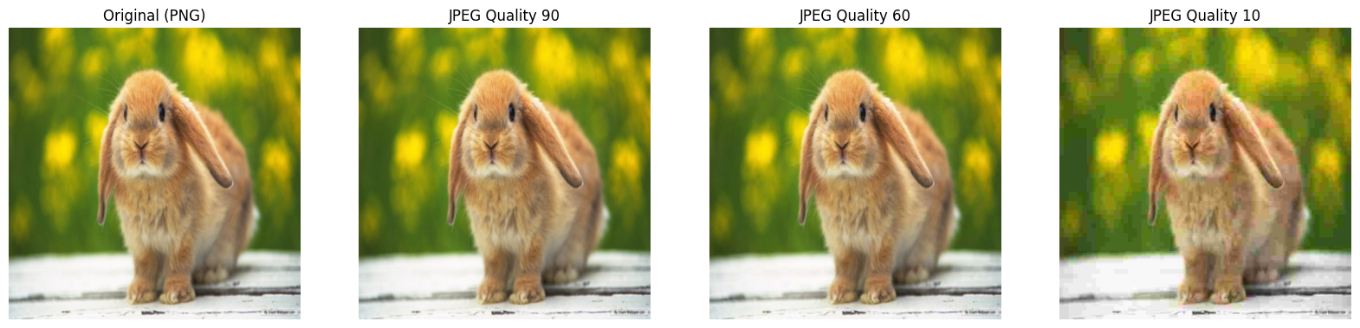
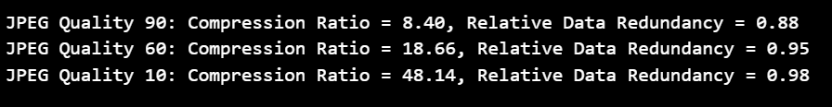
(2)Fidelity Criteria
Code:
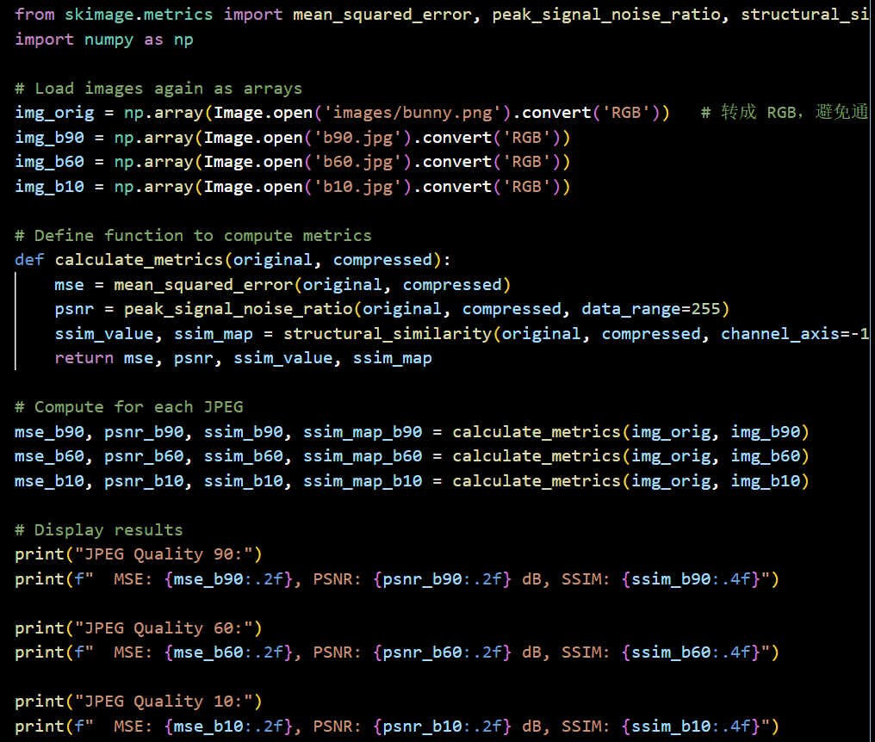
Results:
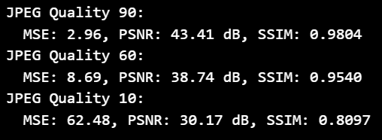
(3)Simulation of a Part of JPEG Compression
Code:
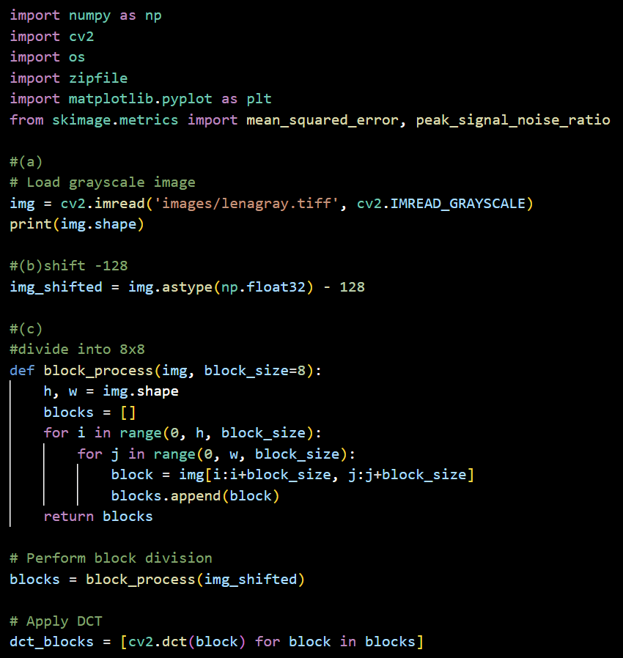
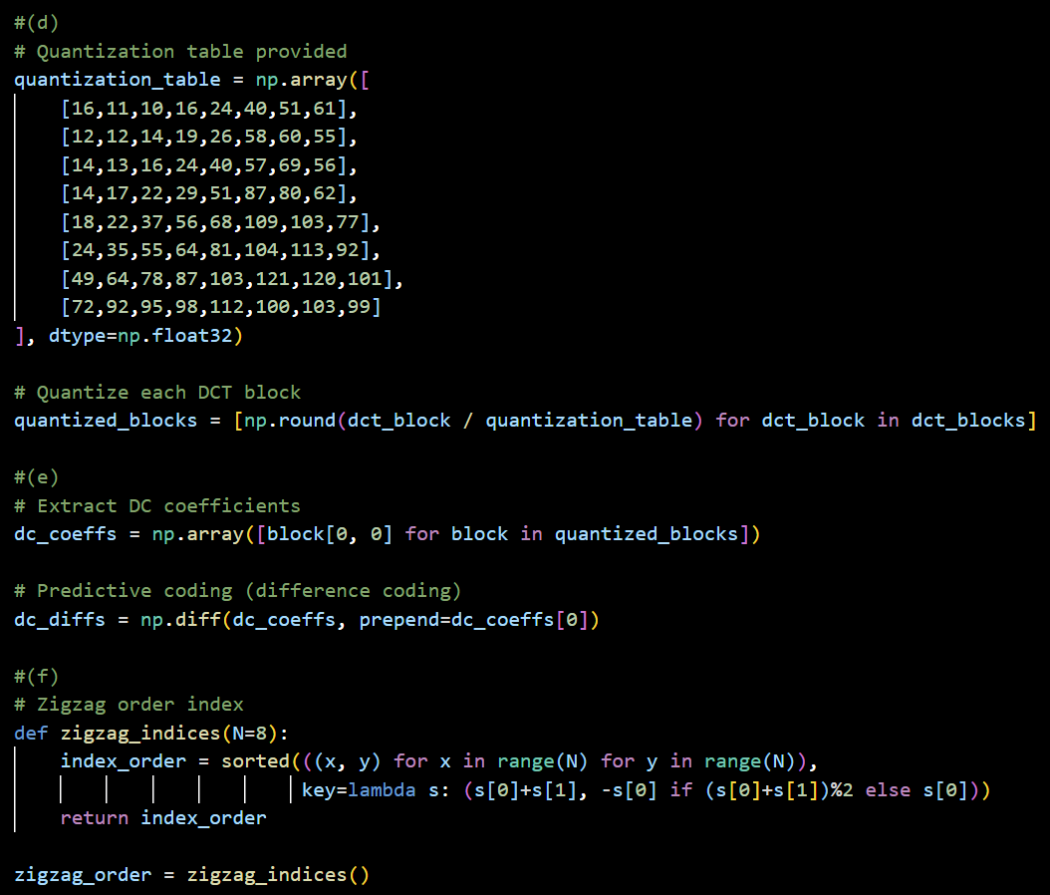
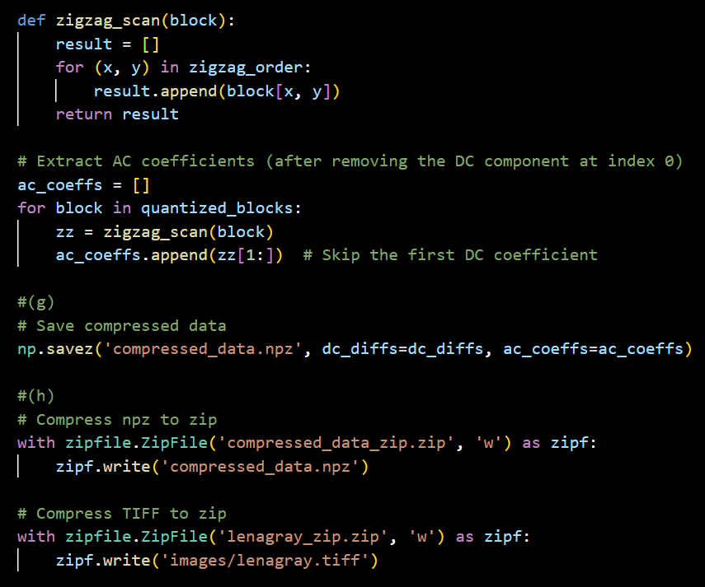
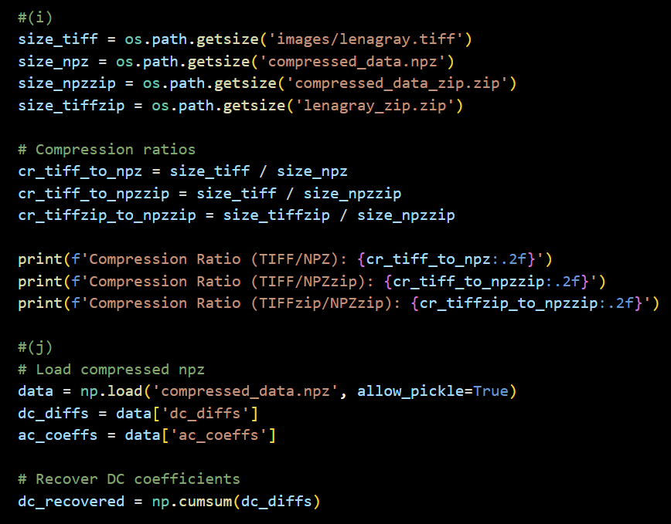

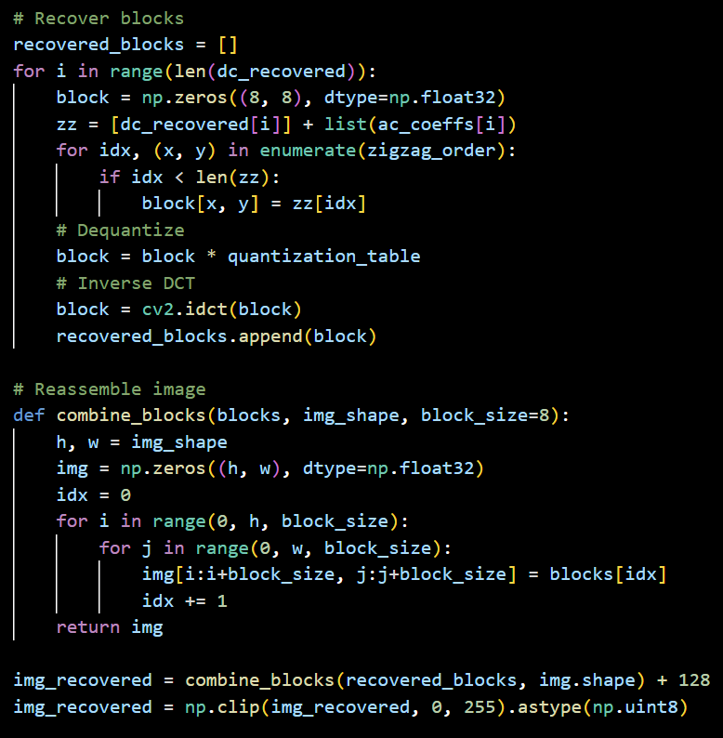
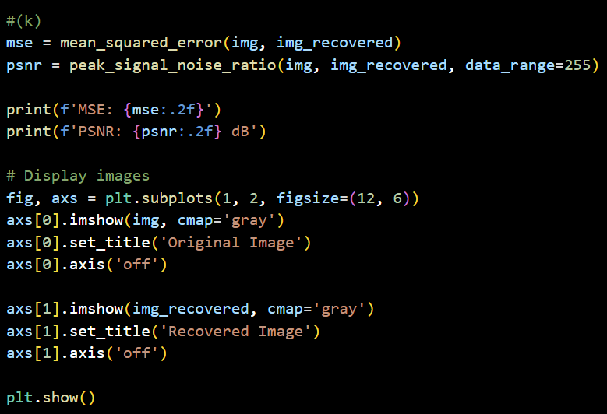
Results:
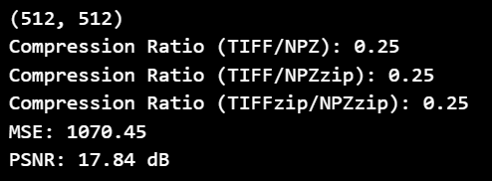
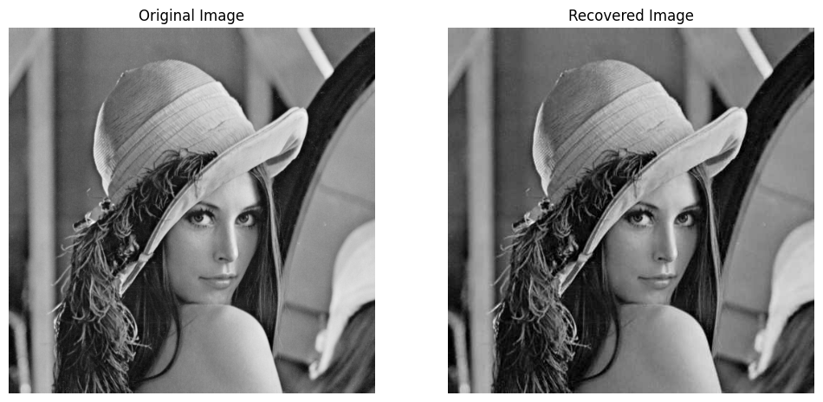

深圳大学学生实验报告用纸
实验分析与结论（Analysis and Conclusion）：
(1)Compression Ratio and Relative Coding Redundancy
The results show that as the quality factor decreases, the file size reduces significantly, leading to a higher compression ratio and greater data redundancy reduction.
However, lower quality factors also result in more visible distortion and artifacts in the images.
Specifically, the compression ratios increased as the quality factor decreased:
At QF=90, the image preserved high fidelity with a slight size reduction.
At QF=60, noticeable compression artifacts appeared, but the storage efficiency improved.
At QF=10, severe visual degradation was observed, though the file size became minimal.
This demonstrates the inherent trade-off between compression efficiency and image quality in JPEG encoding.
(2)Fidelity Criteria
MSE increased as the quality factor decreased, indicating higher distortion.PSNR decreased with lower quality factors, reflecting a lower signal quality relative to the noise introduced by compression.SSIM also dropped significantly at lower quality factors, illustrating the structural degradation of the images.
The bigger the value of PSNR,the less image distortion.The closer the SSIM value is to 1, the better, indicating that the structures of the two images are more similar.
In particular, images compressed at a high quality factor (QF=90) maintained high SSIM and PSNR values, meaning they remained visually similar to the original, while images compressed at QF=10 suffered a considerable loss in both structure and pixel-level accuracy.
These observations quantitatively confirm that lower JPEG quality settings result in increased loss of image fidelity.
(3)Simulation of a Part of JPEG Compression
Compression ratio analysis revealed:The compression ratio of the three is similar.
After decoding the compressed data:The recovered image was visually very close to the original.MSE and PSNR values confirmed that the reconstruction preserved most of the original image quality, with only minor numerical errors.The success of this process demonstrates the effectiveness of DCT-based JPEG compression principles in achieving substantial data size reduction while maintaining acceptable perceptual quality.
指导教师批阅意见：

成绩评定：

实验态度  10分 | 实验步骤及代码  40分 | 实验数据与结果  40分 | 实验分析与结论  10分

指导教师签字：李斌
2025 年 5 月 30 日
备注：

